INDEX

Exp No. | Experiment Name | Date | Page No
01 | Write a C program for Banker’s algorithm for deadlock avoidance. | 08/09/2025 | 2-4
02 | Write a C program to simulate the CPU scheduling algorithm- Shortest Job First (SJF). | 17/05/2025 | 5-6
03 | Write a C program to simulate the CPU scheduling algorithm- Round Robin. | 13/10/2025 | 7-9
04 | Write a C program to simulate the CPU scheduling algorithm - First Come First Serve. | 21/10/2025 | 10-11
05 | Write a C program to implement page replacement technique:  - First In First Out replacement.  - Least Recently Used (LRU) replacement.  - Optimal replacement. | 11/11/2025 | 12-17
06 | Write a C program to simulate the CPU scheduling algorithm - Priority Queue. | 22/12/2025 | 18-19

Problem No: 1
Problem Name: Write a C program for Banker’s algorithm for deadlock avoidance.

Algorithm:
- Initialize:
  - Calculate Need = Max - Allocation
  - Mark all processes as unfinished.
- Find a process whose:
  - Need ≤ Available
- If found:
  - Add its allocation to Available
  - Mark it as finished
  - Add it to safe sequence
- Repeat until all processes finish or no process can proceed.

Source Code:
#include <stdio.h>

int main() {
// Maximum of 5 processes and 3 resource types; increase if needed int p, c, count = 0, i, j;
int alc[5][3]; // Allocation matrix
int max[5][3]; // Maximum demand matrix int need[5][3]; // Remaining need matrix int safe[5]; // Stores safe sequence
int available[3]; // Available resources
int done[5]; // Flags for completed processes int terminate = 0; // Counter to detect unsafe state

printf("Enter the number of processes and resources: ");
scanf("%d %d", &p, &c); // Input number of processes and resource types

// Input allocation matrix
printf("Enter allocation of resources (matrix %dx%d):\n", p, c); for (i = 0; i < p; i++) {
for (j = 0; j < c; j++) { scanf("%d", &alc[i][j]);
}
}

// Input maximum demand matrix
printf("Enter maximum resources required (matrix %dx%d):\n", p, c);

for (i = 0; i < p; i++) { for (j = 0; j < c; j++) {
scanf("%d", &max[i][j]);
}
}
// Input available resources printf("Enter available resources:\n"); for (i = 0; i < c; i++) {
scanf("%d", &available[i]);
}

// Calculate and display need matrix (Need = Max - Allocation) printf("\nNeed matrix (Remaining resource needs):\n");
for (i = 0; i < p; i++) { for (j = 0; j < c; j++) {
need[i][j] = max[i][j] - alc[i][j];
printf("%d\t", need[i][j]);
}
printf("\n");
}

// Initialize done array to track completed processes for (i = 0; i < p; i++) {
done[i] = 0;
}
// Main loop to find safe sequence while (count < p) {
for (i = 0; i < p; i++) { if (done[i] == 0) {
// Check if this process can be executed for (j = 0; j < c; j++) {
if (need[i][j] > available[j]) break;
}
// If all needs can be satisfied if (j == c) {
safe[count] = i; // Add process to safe sequence done[i] = 1; // Mark process as done
for (j = 0; j < c; j++) {
available[j] += alc[i][j]; // Release allocated resources
}
count++;
terminate = 0; // Reset terminate counter
} else {
terminate++; // Count how many could not proceed
}
}
}

// If all remaining processes can't proceed => unsafe state if (terminate == (p - 1)) {
printf("Safe sequence does not exist. System is in an UNSAFE state.\n"); break;
}
}
// If system is in safe state, print results if (terminate != (p - 1)) {
printf("\nAvailable resources after completion:\n"); for (i = 0; i < c; i++) {
printf("%d\t", available[i]);
}
printf("\n\nSafe sequence:\n"); for (i = 0; i < p; i++) { printf("P%d\t", safe[i]);
}
printf("\n");
}
return 0;
}

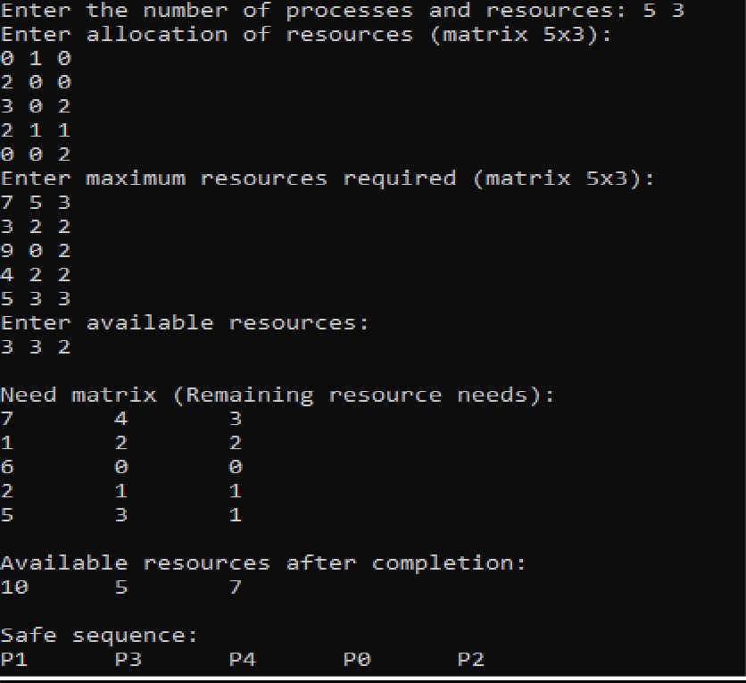
Sample Input & Output:

Problem No: 2
Problem Name: Write a C program to simulate the CPU scheduling algorithm- Shortest Job First (SJF).

Algorithm:
- Input number of processes.
- Input burst time for each process.
- Sort processes in ascending order of burst time.
- Calculate:
  - Waiting Time (WT)
  - Turnaround Time (TAT)
- Calculate average WT and TAT.
- Display results.

Source Code:
#include <stdio.h>

int main() { int n, i, j;
printf("Enter number of processes: "); scanf("%d", &n);

int bt[n], wt[n], tat[n], p[n];

// Input burst time
printf("Enter burst time for each process:\n"); for(i = 0; i < n; i++) {
printf("P%d: ", i);
scanf("%d", &bt[i]); p[i] = i;
}

// Sort processes by burst time (ascending) for(i = 0; i < n - 1; i++) {
for(j = i + 1; j < n; j++) { if(bt[i] > bt[j]) {
// Swap burst time int temp = bt[i]; bt[i] = bt[j];
bt[j] = temp;

// Swap process IDs temp = p[i];
p[i] = p[j];

p[j] = temp;
}
}
}

// Calculate waiting time wt[0] = 0;
for(i = 1; i < n; i++) { wt[i] = wt[i-1] + bt[i-1];
}

// Calculate turnaround time for(i = 0; i < n; i++) {
tat[i] = wt[i] + bt[i];
}

// Display results
float avg_wt = 0, avg_tat = 0;
printf("\nProcess\tBurst Time\tWaiting Time\tTurnaround Time\n"); for(i = 0; i < n; i++) {
printf("P%d\t%d\t\t%d\t\t%d\n", p[i], bt[i], wt[i], tat[i]);
avg_wt += wt[i]; avg_tat += tat[i];
}

printf("\nAverage Waiting Time = %.2f", avg_wt / n); printf("\nAverage Turnaround Time = %.2f\n", avg_tat / n);

return 0;
}

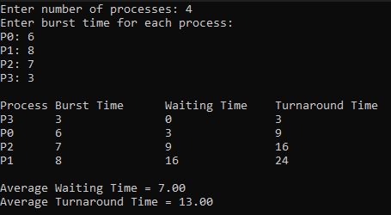
Sample Input & Output:

Problem No: 3
Problem Name: Write a C program to simulate the CPU scheduling algorithm- Round Robin.

Algorithm:
- Input:
  - Number of processes n.
  - Burst time for each process.
  - Time Quantum TQ
- Initialize:
  - Remaining time = Burst time
  - Waiting time = 0
- Repeat until all processes finish.
- Calculate: Turnaround Time = Waiting Time + Burst Time
- Compute averages and display results.

Source Code:
#include <stdio.h>

int main()
{
int cnt, j, n, t, remain, flag = 0, tq;
int wt = 0, tat = 0; // Total waiting time and total turnaround time
int at[10], bt[10], rt[10]; // Arrival Time, Burst Time, Remaining Time arrays

// Input total number of processes printf("Enter Total Process:\t "); scanf("%d", &n);
remain = n; // Number of processes yet to be completed

// Input arrival and burst time for each process for (cnt = 0; cnt < n; cnt++)
{
printf("Enter Arrival Time and Burst Time for Process Number %d :", cnt + 1); scanf("%d", &at[cnt]); // Arrival time
scanf("%d", &bt[cnt]); // Burst time
rt[cnt] = bt[cnt]; // Initialize remaining time
}

// Input the time quantum printf("Enter Time Quantum:\t"); scanf("%d", &tq);

printf("\n\nProcess\t|Turnaround Time|Waiting Time\n\n");

// Round Robin Scheduling Logic for (t = 0, cnt = 0; remain != 0;)
{
// If the process can finish in the given time quantum if (rt[cnt] <= tq && rt[cnt] > 0)
{
t += rt[cnt]; // Increase current time rt[cnt] = 0; // Process completed
flag = 1; // Flag to indicate process completion
}
// If the process needs more time than the time quantum else if (rt[cnt] > 0)
{
rt[cnt] -= tq; // Decrease remaining time

t += tq; // Increase current time
}

// If process is completed, print its turnaround and waiting time if (rt[cnt] == 0 && flag == 1)
{
remain--; // Decrement remaining process count printf("P[%d]\t|\t%d\t|\t%d\n", cnt + 1, t - at[cnt], t - at[cnt] - bt[cnt]); wt += t - at[cnt] - bt[cnt]; // Add to total waiting time
tat += t - at[cnt]; // Add to total turnaround time flag = 0; // Reset flag
}

// Move to the next process
// If at the last process, loop back to first if (cnt == n - 1)
cnt = 0;
// Else, go to the next process if its arrival time has passed else if (at[cnt + 1] <= t)
cnt++;
// If the next process hasn't arrived, start again from the first process else
cnt = 0;
}

// Print average waiting and turnaround times printf("\nAverage Waiting Time= %f\n", wt * 1.0 / n); printf("Avg Turnaround Time = %f", tat * 1.0 / n); return 0;
}

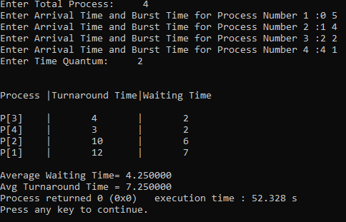
Sample Input & Output:

Problem No: 4
Problem Name: Write a C program to simulate the CPU scheduling algorithm - First Come First Serve.

Algorithm:
- Input number of processes n.
- Input burst time (BT) for each process.
- Assume processes are executed in the order they are entered.
- Calculate:
  - Waiting Time (WT)
  - Turnaround Time (TAT)
- Calculate average WT and TAT.
- Display results.

Source Code:
#include <stdio.h>

int main() { int n, i;
int bt[20], wt[20], tat[20]; // bt = Burst Time, wt = Waiting Time, tat = Turnaround Time float avg_wt = 0, avg_tat = 0;

printf("Enter the number of processes: "); scanf("%d", &n);

// Input burst times
printf("Enter Burst Time for each process:\n"); for (i = 0; i < n; i++) {
printf("P[%d]: ", i + 1);
scanf("%d", &bt[i]);
}

// First process has 0 waiting time wt[0] = 0;

// Calculate waiting time for each process for (i = 1; i < n; i++) {
wt[i] = wt[i - 1] + bt[i - 1];
}

// Calculate turnaround time for each process for (i = 0; i < n; i++) {
tat[i] = wt[i] + bt[i];
}

// Print process details
printf("\nProcess\tBurst Time\tWaiting Time\tTurnaround Time\n"); for (i = 0; i < n; i++) {
printf("P[%d]\t%d\t\t%d\t\t%d\n", i + 1, bt[i], wt[i], tat[i]); avg_wt += wt[i];
avg_tat += tat[i];
}

// Calculate average times avg_wt /= n;
avg_tat /= n;

printf("\nAverage Waiting Time: %.2f", avg_wt); printf("\nAverage Turnaround Time: %.2f\n", avg_tat); return 0;
}

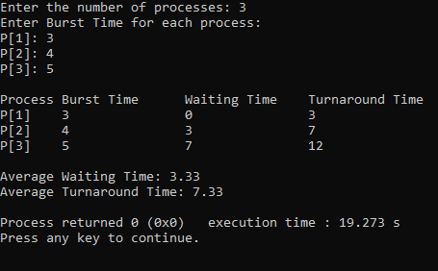
Sample Input & Output:

Problem No: 5
Problem Name: Write a C program to implement page replacement technique:
- First In First Out replacement.
- Least Recently Used (LRU) replacement.
- Optimal replacement.

Algorithm:
First In First Out replacement:
- Start with an empty set of frames.
- For each page in the reference string:
  - If the page is already in memory → Hit
  - Else → Page Fault
- Count total page faults.
Least Recently Used (LRU) replacement:
- Start with empty frames.
- For each page in the reference string:
  - If the page is already in memory → Hit
  - Else → Page Fault
- Keep track of usage using a counter or timestamps.
- Count total page faults.
Optimal replacement:
- Start with empty frames.
- For each page in the reference string:
  - If the page is already in memory → Hit
  - Else → Page Fault
- Count total page faults.

Source Code:
First In First Out replacement:
#include <stdio.h>

int main() {
int frames, pages;
printf("Enter number of frames: "); scanf("%d", &frames); printf("Enter number of pages: "); scanf("%d", &pages);

int ref[pages];
printf("Enter reference string: "); for(int i = 0; i < pages; i++) {
scanf("%d", &ref[i]);
}
int frame[frames];
int front = 0; // Points to oldest page int faults = 0;
// Initialize frames with -1 (empty) for(int i = 0; i < frames; i++) {
frame[i] = -1;

}

printf("\nPage\tFrames\n"); for(int i = 0; i < pages; i++) {
int found = 0;
// Check if page already exists for(int j = 0; j < frames; j++) {
if(frame[j] == ref[i]) { found = 1;
break;
}
}
// If not found → page fault
if(!found) { frame[front] = ref[i];
front = (front + 1) % frames; faults++;
}
// Display frames printf("%d\t", ref[i]);
for(int j = 0; j < frames; j++) { if(frame[j] != -1)
printf("%d ", frame[j]); else
printf("- ");
}
printf("\n");
}
printf("\nTotal Page Faults = %d\n", faults); return 0;
}
Least Recently Used (LRU) replacement:
#include <stdio.h>

int main() {
int frames, pages;
printf("Enter number of frames: "); scanf("%d", &frames); printf("Enter number of pages: "); scanf("%d", &pages);
int ref[pages];
printf("Enter reference string: "); for(int i = 0; i < pages; i++) {
scanf("%d", &ref[i]);
}
int frame[frames], time[frames]; int faults = 0, counter = 0;
// Initialize frames
for(int i = 0; i < frames; i++) { frame[i] = -1;
time[i] = 0;
}

printf("\nPage\tFrames\n"); for(int i = 0; i < pages; i++) {
int found = 0;

// Check for hit
for(int j = 0; j < frames; j++) { if(frame[j] == ref[i]) {
counter++;
time[j] = counter; // Update recent use found = 1;
break;
}
}

// Page fault if(!found) {
int pos = 0;
// Find least recently used page for(int j = 1; j < frames; j++) {
if(time[j] < time[pos]) { pos = j;
}
}

frame[pos] = ref[i]; counter++; time[pos] = counter; faults++;
}

// Display frames printf("%d\t", ref[i]);
for(int j = 0; j < frames; j++) { if(frame[j] != -1)
printf("%d ", frame[j]); else
printf("- ");
}
printf("\n");
}
printf("\nTotal Page Faults = %d\n", faults); return 0;
}
Optimal replacement:
#include <stdio.h>

int main() {
int frames, pages;
printf("Enter number of frames: "); scanf("%d", &frames); printf("Enter number of pages: "); scanf("%d", &pages);
int ref[pages];

printf("Enter reference string: "); for(int i = 0; i < pages; i++) {
scanf("%d", &ref[i]);
}
int frame[frames]; int faults = 0;
// Initialize frames
for(int i = 0; i < frames; i++) { frame[i] = -1;
}
printf("\nPage\tFrames\n"); for(int i = 0; i < pages; i++) {
int found = 0;
// Check for hit
for(int j = 0; j < frames; j++) { if(frame[j] == ref[i]) {
found = 1; break;
}
}
// Page fault if(!found) {
int pos = -1, farthest = i + 1;

for(int j = 0; j < frames; j++) { int k;
for(k = i + 1; k < pages; k++) { if(frame[j] == ref[k]) {
if(k > farthest) { farthest = k; pos = j;
}
break;
}
}
// If page not found in future if(k == pages) {
pos = j; break;
}
}
// If all pages will be used, replace farthest if(pos == -1) {
pos = 0;
}
frame[pos] = ref[i]; faults++;
}
// Display frames printf("%d\t", ref[i]);
for(int j = 0; j < frames; j++) { if(frame[j] != -1)
printf("%d ", frame[j]);

else
printf("- ");
}
printf("\n");
}
printf("\nTotal Page Faults = %d\n", faults); return 0;
}

Sample Input & Output:

First In First Out replacement:
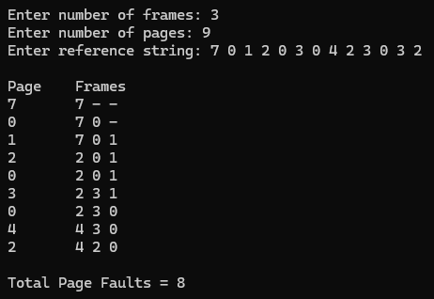
Least Recently Used (LRU) replacement:
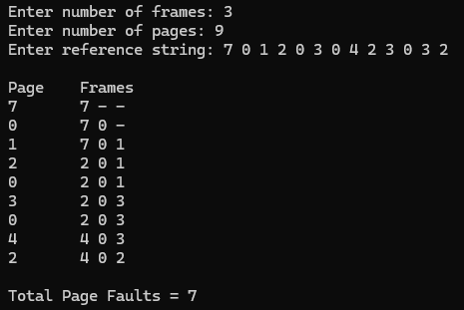

Optimal replacement:
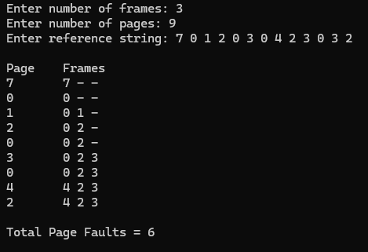

Problem No: 6
Problem Name: Write a C program to simulate the CPU scheduling algorithm - Priority Queue.

Algorithm:
- Input number of processes n.
- Input:
  - Burst Time (BT).
  - Priority (P).
- Assign process IDs.
- Sort processes based on priority (ascending).
- Calculate:
  - Waiting Time (WT).
  - Turnaround Time (TAT).
- Compute averages.
- Display results.

Source Code:
#include <stdio.h>

int main() { int n, i, j;
printf("Enter number of processes: "); scanf("%d", &n);

int bt[n], pr[n], wt[n], tat[n], p[n];

// Input burst time and priority
printf("Enter Burst Time and Priority for each process:\n"); for(i = 0; i < n; i++) {
printf("P%d (BT Priority): ", i);
scanf("%d %d", &bt[i], &pr[i]); p[i] = i;
}

// Sort based on priority (lower value = higher priority) for(i = 0; i < n - 1; i++) {
for(j = i + 1; j < n; j++) { if(pr[i] > pr[j]) {
// Swap priority int temp = pr[i]; pr[i] = pr[j]; pr[j] = temp;

// Swap burst time temp = bt[i];

bt[i] = bt[j]; bt[j] = temp;

// Swap process ID temp = p[i];
p[i] = p[j]; p[j] = temp;
}
}
}

// Calculate waiting time wt[0] = 0;
for(i = 1; i < n; i++) { wt[i] = wt[i-1] + bt[i-1];
}

// Calculate turnaround time for(i = 0; i < n; i++) {
tat[i] = wt[i] + bt[i];
}

// Display results
float avg_wt = 0, avg_tat = 0;
printf("\nProcess\tPriority\tBurst Time\tWaiting Time\tTurnaround Time\n"); for(i = 0; i < n; i++) {
printf("P%d\t%d\t\t%d\t\t%d\t\t%d\n", p[i], pr[i], bt[i], wt[i], tat[i]); avg_wt += wt[i];
avg_tat += tat[i];
}
printf("\nAverage Waiting Time = %.2f", avg_wt / n); printf("\nAverage Turnaround Time = %.2f\n", avg_tat / n); return 0;
}

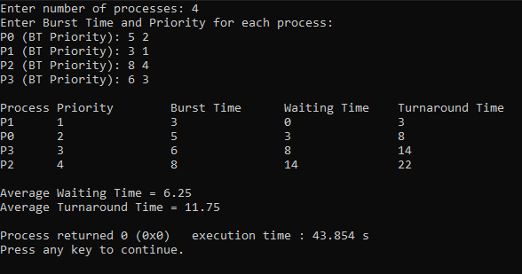
Sample Input & Output:

